Meta-Analysis of short-term efficacy of ketamine in major depression patients

*Adam Russel, Pamela Inostroza - Master in Statistics, KU Leuven*

**Gravity of depression**

Cities and societies around the world today face many modern and unprecedented challenges. Many people, from all backgrounds, struggle to adapt to aspects of reality regarding their social, professional, or philosophical situations, and these struggles can often manifest themselves in a variety of different ways, such as stress, anxiety and depression. The cause of depression, as specified by the World Health Organisation, is a complex interaction of social, psychological, and biological factors. This complexity extends to treatment, with cases of depression often being chronic, resistant to treatment, and comorbid with other disabilities, adding further complications.

Not only is the prevalence of depression a clear indicator of this disability’s importance, its cost, both in an economical sense as well as phenomenological, is also critical. Many adults today have either experienced depression, or know someone who has, and the experience is nothing to take lightly. An author well-acquainted with the subject writes, *depression is actually much more complex, nuanced, and dark than unhappiness – more like an implosion of self. In a serious state of depression, you become a sort of half-living ghost* (Lott, 2016)*.* This dire, and in fact terrifying, account of such a condition only serves to emphasise the importance of determining effective treatments for what is, essentially, a treatable disorder.

**Introduction to ketamine**

For these reasons, many treatments for depression are already in practice, with varying measures of success. These treatments can involve pharmaceutical treatments (antidepressants, such as SSRIs or tricyclic treatments), psychotherapy (such as CBT or mindfulness therapy), brain stimulation therapy (such as ECT or transcranial magnetic stimulation), among many others (Mayo Clinic, 2019). New patients often need to experiment with several treatments in turn before finding something that works for them.

As well as this issue of mixed results for different individuals (those suffering from what is termed treatment-resistant (TR) depression), there are two other key issues with those treatments listed above. They are slow (often taking weeks, months or even years to take effect), and they often incur side effects, ranging from mild to life-threatening (which can cause discontinuation of treatment before clinical improvements). The importance of a treatment that could offer immediate or fast acting relief to depression is thus paramount.

In 2019, the FDA approved the first truly new medication for major depression in decades; an anaesthetic drug called Ketamine (Chen, 2019). The chemical has been known for a long time and has had quite a turbulent history. The first commercial use began in Belgium, who patented the drug in 1963 as a veterinary anaesthetic (or horse tranquiliser). Shortly after, researchers from all over the world began exploring the drug in the sixties and seventies as a general anaesthetic, with publications coming from all over the world (Mion, 2017). Its recreational use and abuse, however, led researchers to acknowledge the drug’s euphoric and psychedelic properties, leading to initial investigations into the drug’s suitability for palliative care (Jansen, 2001). This led to the first trials of Ketamine as a treatment for depression (Berman et al. 2000).

Since 2001, there has been an abundance of clinical trials assessing how ketamine performs as a treatment for depression, specifically, for treatment resistant depression and for those at risk for suicide. The reason for this is that the biological mechanism underlying the therapeutic effect of ketamine is both very fast acting, and unique from other treatments, meaning patients who have not benefited from existing treatments could benefit from Ketamine (Zarate & Niciu, 2015), especially if they are an immediate danger to themselves. Many of these trials report very positive results, inciting a media response and general excitement, which introduces a risk of hype and bias. This makes the importance of vigorous testing (to avoid dangerous or ineffective treatments) even more important. The objective of this paper is to perform a meta-analysis on ketamine effectiveness, by aggregating the results of a sample of clinical trials on Ketamine.

**Meta-analysis in general**

Meta-analysis is a statistical method for aggregating existing results from multiple studies. The benefit of such an endeavour is to produce a global result with greater statistical power than derived from any individual study. Such a method is appropriate when there are multiple scientific studies addressing the topic in question, where each study can be seen as estimating a true effect (or range of effects) with a certain degree of error. The meta-analysis will derive a pooled estimate that will theoretically be closer to the true effect (or represent the mean of effects in question).

Numerous clinical trials have been conducted on the safety and efficacy of Ketamine as a rapidly acting treatment for depression. These trials vary in many important ways that affect their results and make a simple comparison of trials complicated. The most important ways in which these trials can vary are listed in Table 1.

Table 1: Ways in which clinical trials on ketamine can vary

|  |  |
| --- | --- |
| Design | Study designs vary widely; these may involve how the subjects are organised (independent groups or case crossover), when they are measured (hourly, daily), and who they are compared to (placebo or active treatment) |
| Participants | Baseline characteristics may vary between studies (such as nationality, age, sex, SES) as well as selective characteristics, depending on the nature of the trial (history of depression and previous treatments, other ongoing treatments) |
| Depression | Trials have typically focussed on treatment resistant depression, major depressive disorder, and bipolar depression. These are defined and measured with different psychological metrics. |
| Ketamine | Ketamine has a few molecular variations (esketamine, ketamine hydrochloride), can be administered differently (orally, nasally, intravenously), and in different doses |

Other methods to address these differences between trials exist, which can involve including these variables as factors in a multilevel meta-analysis, or covariates in a regression meta-analysis. Indeed, previous research has indicated that ketamine affects males and females different, as well as there being an age effect and even an interaction between age and sex (Derntl et al, 2019). These variables are therefore interesting candidates as regression parameters.

**Methods**

**Search strategy and criteria for selection**

To begin the analysis, academic articles were searched online via the KU Leuven university database (Limo) as well as Google Scholar. Generic keywords were used to find all articles resembling clinical trials on ketamine, giving a list of 20 articles.

These articles were reviewed, and a sample kept being used in the meta-analysis according to a selection criterion. The selection criteria were defined such that those studies included in the analysis would form a coherent and comparable group; each asking a relatively similar question of the data and using relatively similar tools to do so. The selection criteria were as follows.

* Study is a randomised, placebo-controlled clinical trial
* The experimental group is administered at least with one dose of ketamine
* All subjects are diagnosed with either major depressive disorder (MDD) or bipolar depression (BP)
* The study uses the Montgomery–Åsberg Depression Rating Scale (MADRS) as a metric for depression
* Depression is measured 24 hours after ketamine is administered

Using only studies that use the MADRS is a matter of convenience; this is the metric used by the vast majority of trials concerning depression and having a uniform metric in our meta-analysis simplifies things immensely. In addition, this criterion only eliminates one study that would otherwise be included (eliminated study; Fava et al. 2018).

Using only studies that have a measurement 24 hours after ketamine administration relates to the question being investigated. We are primarily interested in whether ketamine could be beneficial for patients who require immediate relief from their depressive episode and cannot wait for the slower effects of traditional treatments or therapies. The trials reviewed contained measurements ranging from hourly to weekly, but 24 hours suits our research question and was a commonly measured time point. When these selection criteria were applied to the 20 articles found in the online search, all but 7 were filtered out. The 7 remaining articles were clinical trials conforming to the selection criteria outlined above, the key features of which are summarised in Appendix A.

In order to pool the data from the different trials to calculate an overall effect, the results of each individual trial must be standardised. This was done by collecting the sample sizes and means for the control and experimental groups in each study and using these data to calculate a standardised effect size (Cohen’s D) for each trial. Two trials included in this meta-analysis (Singh et al. 2016, and Daly et al. 2018) contained multiple experimental groups, each with different doses of ketamine. These are included as levels within the meta-analysis. Cohen’s D for each experimental group is included in the table in Appendix A.

**Statistical analyses**

To perform the meta-analysis, these studies were first analysed all together, using a random effects model, and the results and heterogeneity of this model were assessed. We considered the possibility of publication bias in our sample of selected studies via an analysis of funnel plots. We then looked at more advanced analyses; subgroup analyses, a regression model to include the effect of covariates and a multilevel model to account for dependency within the data. Finally, we discuss measures of the power of the analysis.

In a random-effects model meta-analyses, it is not only assumed that effects of individual studies deviate from a true effect size due to sampling variance (${se}^{2}$), but that there is another source of variance introduced by the fact that the studies do not stem from one single population ($\hat{τ}$), but are drawn from a “universe” of populations. We can use the heterogeneity of our studies to estimate the variance of this universe of populations. Heterogeneity is addressed by examining the following.

* *Clinical baseline heterogeneity*, which can be defined as the differences in participant characteristics, types or timing of outcome measurements and intervention characteristics between different studies
* *Statistical heterogeneity* in the collected effect size is calculated with Cochran’s *Q*-statistic, which is the difference between the observed effect sizes and the fixed-effect model estimate of the effect size, which is then squared, weighted and summed
* Higgin’s & Thompson’s $I^{2}$ measures the percentage of variability in the effect sizes due to this heterogeneity (as opposed to chance or sampling error)
* Tau-squared ($τ^{2}$), which is a measure for the between-study variance in our meta-analysis, and can reflect the variance of the true effect sizes

**Results**

Seven different studies were included in the analysis, two of which include multiple experimental groups (with different doses of ketamine; these were [Singh et al. 2016](https://www.zotero.org/google-docs/?Lb4GNe) and [Daly et al. 2018.)](https://www.zotero.org/google-docs/?y5YlOr) Of the seven studies, four had a crossover design [(Lapidus et al. 2014](https://www.zotero.org/google-docs/?FkqFtf), [Zarate et al. 2012](https://www.zotero.org/google-docs/?Ntnn11), [Diazgranados et al. 2010](https://www.zotero.org/google-docs/?7il3Xd), and [Sos et al. 2013)](https://www.zotero.org/google-docs/?4nHGfh), meaning that the participants acted as their own control (after a washout period). Conversely, the remaining three studies [(Singh et al. 2016](https://www.zotero.org/google-docs/?qwYjtH), [Daly et al. 2018,](https://www.zotero.org/google-docs/?a0Td8L) and [Murrough et al. 2013)](https://www.zotero.org/google-docs/?bLck0j) use two independent groups of participants for the treatment and control. Intravenous infusion or intranasal interventions of ketamine hydrochloride or esketamine are used in the studies as detailed in Appendix A. In total, one hundred and eighty-one participants received ketamine or esketamine, and two hundred twenty-two received placebo.

**Overall effect**

Standardised effect sizes (as shown in Appendix A) were worked with in R using the package “meta” to conduct the meta-analysis with a random effects model. All the calculated effect sizes were negative, meaning that the studies were all in agreement; depression measurements in the ketamine groups were lower than the control groups (greater feelings of depression mean high MADRS score). A forest plot was generated which clearly shows the similar results found in the sample of selected studies, which is shown in Figure 1.

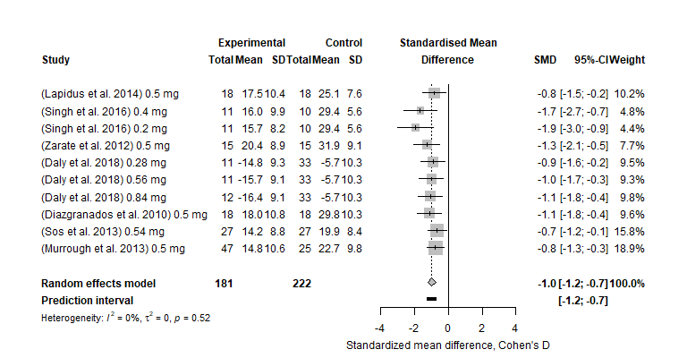

Figure 1: Forest plot for meta-analysis

We see in Figure 1 that, for our sample of studies, there was not much variation in either the effect size or the variance of the effect-size. The implication of this is that, despite the different calculation for the weights between the fixed and random effects model, the results are very similar, as the variation between the studies can largely be attributed to sampling variance (that is, our studies do not appear to have heterogeneity). This is corroborated statistically, in that we can observe that the global effect of ketamine on the depression scores at 24hours post-treatment was significantly improved in patients receiving ketamine compared to controls (SMD = -1.0; 95% CI: [-1.2;-0.7]). No heterogeneity in the studies is found, as indicators Higgin’s & Thompson’s I2 and 2are equal to 0. It is important to note, however, that this first model is not taking into account any of the details discussed above, such as the fact that there are multiple groups belonging to the same studies, or any covariates.

**Subgroup Analysis**

We then proceeded to a subgroup analysis and compared those studies with independent groups with the crossover trials. This yielded very similar results; the ketamine treatment was deemed equally effective in studies with a crossover design (SMD = -0.9; 95% CI: [-1.3;-0.5]) than studies with two independent groups (SMD = -1.0; 95% CI: [-1.4;-0.6]). These results are shown in the forest plot in Figure 2.

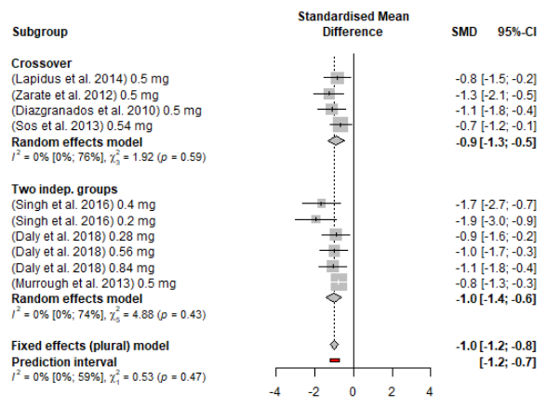

Figure 2: Subgroups; Crossover design and Independent Groups

**Publication Bias**

An additional consideration taken in this analysis involves the possibility of the results being affected by publication bias. As all the studies used in this meta-analysis come from published trials with significant results, there is a possibility that unpublished trials with conflicting results may exist, while not being included in this analysis. The ‘trim and fill’ method is used to identify and correct for asymmetry that can be seen in a funnel plot, arising from publication bias. The basis of this method is to remove the smaller studies causing funnel plot asymmetry, and to use the trimmed funnel plot to estimate the true ‘centre’ of the funnel, then replace the omitted studies and their missing ‘counterparts’ around the centre. As well as providing an estimate of the number of missing studies, an adjusted intervention effect is derived by performing a meta-analysis including the filled studies.

Results remain significant after adjustment for bias, using trim and fill method for estimating numbers and outcomes of missing studies in a meta-analysis (SMD = -0.9; 95% CI: [-1.2;-0.6]) and heterogeneity indicator $I^{2}$ increase to 29%, which is still considerate as low heterogeneity. The funnel plot is shown in Figure 3, where we can see two studies added to provide symmetry. The effects of this adjustment on the overall results is negligible, indicating that publication bias does not seem likely to be a large influence.

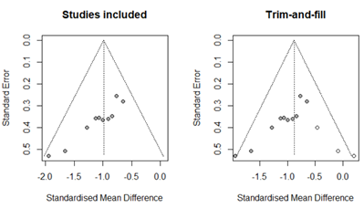

Figure 3: Funnel plots

**Meta Regression and Multilevel modelling**

As discussed in the introduction, previous research has indicated that the effect of ketamine may be modified by age and sex. For our studies, while we found a positive relation between the standardized mean difference and the percentage of females in the studies this was not statistically significant, and not find any significant covariates in a meta regression. This is likely due to the baseline sample characteristics of our studies being quite similar; for the most part, they worked with population samples of similar mean ages and sexes. If there were extreme differences between the study populations in the covariate in question, its effect would be much more pronounced. Likewise, we found no significant relation between the standardized mean difference and the publication year, nor the amount of ketamine doses in the intervention of each study. These meta-regressions are visualised in Figure 4.

A more sensitive analysis of these covariates would involve splitting each individual study according the covariate in question, then pooling the subgroups across the studies (all the females from all the studies compared to all the males from all the studies). However, the reported data in our sample of studies was too often pooled across sex and age, so it was not possible generate a standardised effect for each study across these potential covariates.

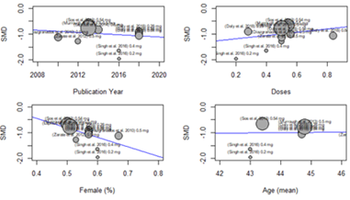

Figure 4: Visualisations of Covariates Analysed in Meta Regression

Multilevel modelling was studied in order to include different research from same teams as nested studies, for this, Author level was included in a multilevel model, nevertheless, this level would not consist in enough variability to perform to type of analysis.

**Discussion and conclusion**

This meta-analysis, based on the primary data obtained from authors of seminal studies, showed that ketamine was effective, as compared with placebo, in treatment-resistant major depressive episode and that this efficacy was significant at the first day of treatment.

The main limitation of our meta-analysis was the limited number of trials and data included in the analyses and despite a comprehensive review of the literature, the use of stringent inclusion criteria, and the examination of potential publication bias, only 7 research studies were included in this meta-analysis. As only four doses were used (0.2, 0.4, 0.5, 0.8 mg/kg), it was not possible to carry out a correlation to highlight a dose effect.

Poor available data may be responsible the absence of significant relationship between demographic and clinical characteristics and ketamine's efficacy. Patients with alcohol dependence and substance abuse were excluded in most of the studies, as well as those with a history of psychotic episode. These results can therefore not be extrapolated to patients with psychotic features, especially in regard to the risk of dissociation and derealization that is described in the transient side effects of ketamine.

Further studies should focus in which way ketamine may be most effective when combined with cognitive behavioural therapy (CBT) this way FDA approval of esketamine gives doctors another valuable tool in their arsenal against depression—and offers new hope for patients no one had been able to help before.

# References

Berman et al. (2000) Antidepressant effects of ketamine in depressed patients. *Biological Psychiatry*; 47:351–354.

Chen, Jennifer. (2019) How New Ketamine Drug Helps with Depression. *Yale Medicine*. Accessed via; <https://www.yalemedicine.org/stories/ketamine-depression>

[Daly, Ella J., Jaskaran B. Singh, Maggie Fedgchin, Kimberly Cooper, Pilar Lim, Richard C. Shelton, Michael E. Thase, Andrew Winokur, Luc Van Nueten, Husseini Manji, and Wayne C. Drevets. 2018. ‘Efficacy and Safety of Intranasal Esketamine Adjunctive to Oral Antidepressant Therapy in Treatment-Resistant Depression: A Randomized Clinical Trial’. *JAMA Psychiatry* 75(2):139.](https://www.zotero.org/google-docs/?ploOFy)

Derntl B. et al. (2019) Interaction of Sex and Age on the Dissociative Effects of Ketamine Action in Young Healthy Participants. *Frontiers in Neuroscience*. Vol 13, article 616. Accessed via; https://www.frontiersin.org/articles/10.3389/fnins.2019.00616/full

[Diazgranados, Nancy, Lobna Ibrahim, Nancy E. Brutsche, Andrew Newberg, Phillip Kronstein, Sami Khalife, William A. Kammerer, Zenaide Quezado, David A. Luckenbaugh, Giacomo Salvadore, Rodrigo Machado-Vieira, Husseini K. Manji, and Carlos A. Zarate Jr. 2010. ‘A Randomized Add-on Trial of an N-Methyl-D-Aspartate Antagonist in Treatment-Resistant Bipolar Depression’. *Archives of General Psychiatry* 67(8):793–802.](https://www.zotero.org/google-docs/?ploOFy)

Fava, Maurizio, Marlene P. Freeman, Martina Flynn, Heidi Judge, Bettina B. Hoeppner, Cristina Cusin, Dawn F. Ionescu, et al. 2018. ‘Double-Blind, Placebo-Controlled, Dose-Ranging Trial of Intravenous Ketamine as Adjunctive Therapy in Treatment-Resistant Depression (TRD).’ *Molecular Psychiatry*, October. https://doi.org/10.1038/s41380-018-0256-5.

Harrer, Mathias, Pim Cuijpers, and David Ebert. 2019. ‘Doing Meta-Analysis in R’, January. https://doi.org/10.5281/ZENODO.2551803.

Jansen, Karl (2001) Ketamine: Dreams and Realities. Published by MAPS.

[Lapidus, Kyle A. B., Cara F. Levitch, Andrew M. Perez, Jess W. Brallier, Michael K. Parides, Laili Soleimani, Adriana Feder, Dan V. Iosifescu, Dennis S. Charney, and James W. Murrough. 2014. ‘A Randomized Controlled Trial of Intranasal Ketamine in Major Depressive Disorder’. *Biological Psychiatry* 76(12):970–76.](https://www.zotero.org/google-docs/?ploOFy)

Lott, Tim, (2016). What does depression feel like? Trust me – you really don’t want to know. *The Guardian*. Accessed via www.theguardian.com/commentisfree/2016/apr/19/depression-awareness-mental-illness-feel-like

Mayo Clinic (2019) Depression: *major depressive disorder*. Accessed via; www.mayoclinic.org/diseases-conditions/depression/diagnosis-treatment/drc-20356013

Mion, Georges. (2017) History of anaesthesia: The ketamine story – past, present and future. *European Journal of Anaesthesiology*. Volume 34(9) pages 571-575.

[Murrough, James W., Dan V. Iosifescu, Lee C. Chang, Rayan K. Al Jurdi, Charles E. Green, Andrew M. Perez, Syed Iqbal, Sarah Pillemer, Alexandra Foulkes, Asim Shah, Dennis S. Charney, and Sanjay J. Mathew. 2013. ‘Antidepressant Efficacy of Ketamine in Treatment-Resistant Major Depression: A  Two-Site Randomized Controlled Trial.’ *The American Journal of Psychiatry* 170(10):1134–42.](https://www.zotero.org/google-docs/?ploOFy)

[Singh, Jaskaran B., Maggie Fedgchin, Ella Daly, Liwen Xi, Caroline Melman, Geert De Bruecker, Andre Tadic, Pascal Sienaert, Frank Wiegand, Husseini Manji, Wayne C. Drevets, and Luc Van Nueten. 2016. ‘Intravenous Esketamine in Adult Treatment-Resistant Depression: A Double-Blind, Double-Randomization, Placebo-Controlled Study’. *Biological Psychiatry* 80(6):424–31.](https://www.zotero.org/google-docs/?ploOFy)

[Sos, Peter, Monika Klirova, Tomas Novak, Barbora Kohutova, Jiri Horacek, and Tomas Palenicek. 2013. ‘Relationship of Ketamine’s Antidepressant and Psychotomimetic Effects in Unipolar  Depression.’ *Neuro Endocrinology Letters* 34(4):287–93.](https://www.zotero.org/google-docs/?ploOFy)

World Health Organisation (2020) Depression Fact Sheet. Accessed via; www.who.int/news-room/fact-sheets/detail/depression

[Zarate, Carlos A., Nancy E. Brutsche, Lobna Ibrahim, Jose Franco-Chaves, Nancy Diazgranados, Anibal Cravchik, Jessica Selter, Craig A. Marquardt, Victoria Liberty, and David A. Luckenbaugh. 2012. ‘Replication of Ketamine’s Antidepressant Efficacy in Bipolar Depression: A Randomized Controlled Add-On Trial’. *Biological Psychiatry* 71(11):939–46.](https://www.zotero.org/google-docs/?ploOFy)

Zarate, C. & Niciu MJ. (2015) Ketamine for depression: evidence, challenges and promise. *World Psychiatry* 14:348–350.

# Appendix A

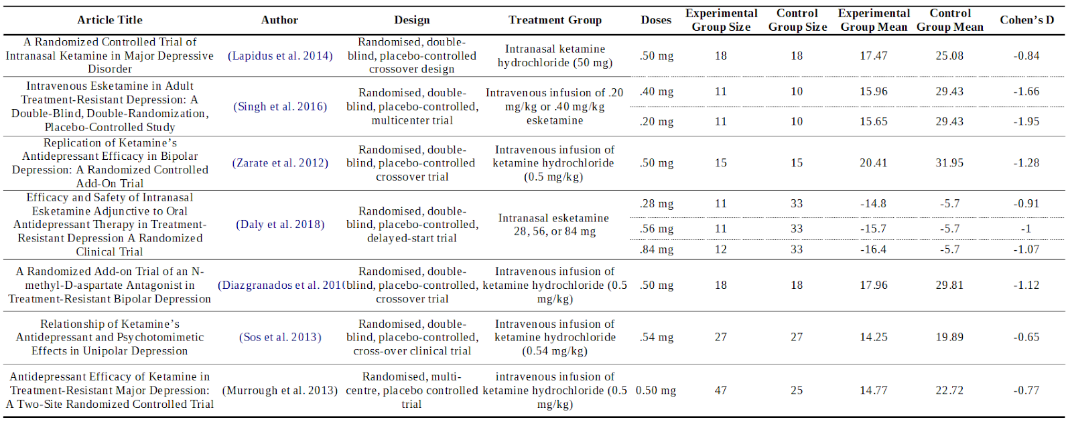

Figure 5: Articles included in meta-analysis